**Grades:**

60% will be tests and assessments

40% will be assignments and projects

We have one quiz a week if there is no unit test and one unit test every few weeks. We also use Eagle Assessments online to assist in preparing for the End of Course exam.

We do many projects and assignments in class. Most homework will simply be a form of research or review.

**Class Calendar (ecahistory.weebly.com):**

**Due to the nature of block scheduling, it is very important that your child is in class. Please schedule all appointments on a day other than a test day or review day. I have noticed already how much attendance plays in learning this material.**



**Communication**

Education is a partnership between home and school. In order for this partnership to be effective, we need to be able to communicate!

Email is the best way to contact me – [kfrey@evangelacademy.com](mailto:kfrey@evangelacademy.com). I will try my best to get back to you within a few hours. I am always available to schedule a conference to discuss any issue or concern you have regarding your child. Just contact the counselor!

I keep a blog on the class website (ecahistory.weebly.com) so you can see pictures and read about what we do on a weekly basis. Just click on the blog tab and type in the password (simon). I wish I could go to school with my son and see everything that he does so I created the blog so you can see interesting things that we do in the classroom!

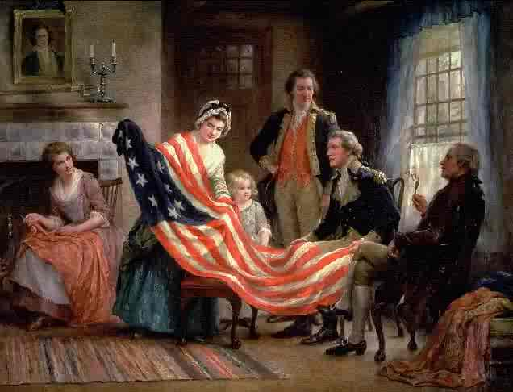

*A Parent’s Guide*

*To History class!*

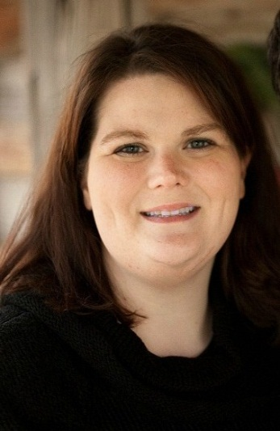

Mrs. Frey

**Evangel Christian Academy**







**Homework:**

Your child will have homework every day except Wednesday - due to the nature of block scheduling, we have to move quickly. Most of the homework will be on the class website or written. If there is a technology problem, simply ask your child to call a friend and write out the homework to turn in the next day. No problem!

**About Me:**

I am an experienced teacher (going on 7 years) who has a passion for students! My original calling was to teach Spanish and I loved that but I found myself enjoying the culture and history of the Hispanic people more than teaching grammar so I switched to History. It is a blast! I have 2 years of experience in a public school setting and this is my 5th year at ECA! I have an undergraduate degree in American Military History and Spanish, a Master’s degree in Education and a Master’s degree in American History. I am certified for the state of Louisiana to teach Social Studies 7-12 and Spanish 6-12. Go Eagles!



**Ways to get info out of your child!:**

* Opposites – What was the best thing about your day? What was the worst thing? (my dad’s personal favorite) What was the most memorable classroom activity? The most boring?
* Activity – try to talk to your child while doing an activity together.
* Two truths & a wish! Ask your child to tell you two things that did happen that day and one thing your child wished that happened. Try to guess which ones are the truths and which one is the wish!
* If all else fails, join my celly group! Text @ushistory2012 to 23559 to receive homework reminders and test reminders that I send the students.

